Notebook 1: How to Initialize a Node.js Project

Node.js is an app that helps you run servers.

# Requirements

* Command Prompt
* File Explorer

# Installing Node.js

If you haven’t already, you need to install Node.js.

1. Go to <https://nodejs.org/en/download/>
2. Select “Windows Installer”

# Creating a project folder

#### A project folder helps keep everything organized.

1. Open File Explorer and right-click an empty space.
2. Select “New”, then “Folder” to create your folder. You can name it whatever you want; I’ll be calling mine “Testing”.

# Using “npm init”

1. Copy the file path of your new folder:

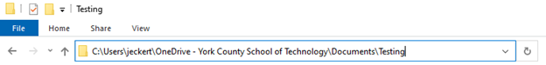

1. Open Command Prompt and enter the following to switch to your folder:

### cd [[file path]]

Note: In these tutorials, double square brackets indicate placeholders.

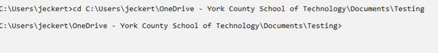

1. Enter the following commands:

### npm init

### npm i

* 1. Input the information it asks as you see fit. You can spam the enter key, but I highly recommend taking the time to fill it in.

1. If it worked, you should see something inside your folder.

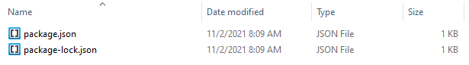

# Making the main .js file

1. In your folder, select “New”, then “Text Document”.
2. Replace the .txt at the end with .js. Name the document anything you want to.
   1. If you don’t see the .txt, you don’t have file extensions on. At the top of your File Explorer, select “View” then “File name extensions”.
3. The next entry will tell you how to make your file. Once it’s done, you’ll be able to run it like this:

### node [[file name]].js